मध्यप्रदेश शासन | Government of Madhya Pradesh
सहकारिता विभाग | Co-operation Department
USER MANUAL
निरीक्षण मॉड्यूल — Nirikshan Module
Parakh GIS Portal — MP Cooperative Society
gisuat.mp.gov.in/parakhweb/

Document Type | User Manual
System | Parakh GIS Web Portal
Module | Cooperative Society Inspection & Roster Assignment
Department | Co-operation Dept., Govt. of Madhya Pradesh
URL | gisuat.mp.gov.in/parakhweb/
Version | 1.0 | June 2026
Audience | State Admin, Nodal Officers, Nirikshankarta (Field Inspectors)

1. Introduction | परिचय
This User Manual provides step-by-step instructions for using the
Nirikshan (Inspection) Module of the Parakh GIS Portal (gisuat.mp.gov.in/parakhweb/) for the MP Cooperative Department. It covers:

- Setting up Master Data — Designations and Users
- Managing the User List
- Creating and managing Inspection Rosters (निरीक्षण रोस्टर)
- Viewing Inspection Reports (निरीक्षण प्रतिवेदन)
- Using the Admin Dashboard

Role / भूमिका | Relevant Sections
State Admin (राज्य एडमिन) | 1 → 7 (All sections)
Nodal Officer (नोडल अधिकारी) | Section 5 – View Inspection; Section 6 – Dashboard
Nirikshankarta (निरीक्षणकर्ता) | Section 5 – View Inspection; Section 6 – Dashboard

2. Portal Login | पोर्टल में लॉगिन

2.1 How to Access the Portal
- Step 1: Open a web browser (Google Chrome or Mozilla Firefox recommended).
- Step 2: Type the URL in the address bar: gisuat.mp.gov.in/parakhweb/
- Step 3: Enter your Username (उपयोगकर्ता नाम) and Password (पासवर्ड).
- Step 4: Click the Login button.

📌 Note | नोट
The portal supports Chrome, Firefox, and Edge. Use a minimum screen resolution of 1280 × 768. Internet speed should be at least 2 Mbps for smooth operation.
यदि पासवर्ड भूल गए हों तो बाएँ मेनू में "Reset Password" विकल्प का उपयोग करें।

2.2 Navigation Menu (Left Sidebar)
After login, the left sidebar shows the following menu items:

Menu Item | हिंदी नाम | Function
Rooster List | रोस्टर सूची | Create and manage annual inspection rosters
View Inspection | निरीक्षण देखें | View list of inspected offices and report summaries
Master | मास्टर | Sub-menu: Create Designation, Create User
User List | उपयोगकर्ता सूची | Search and manage all portal users
Circular/Notification | परिपत्र / अधिसूचना | View department circulars and notifications
Reset Password | पासवर्ड बदलें | Change your portal password

3. Master Setup | मास्टर सेटअप
Before creating users or rosters, the State Admin must set up master data — designations and user accounts.

3.1 Create Designation | पदनाम बनाएँ
Go to: Master → Create Designation

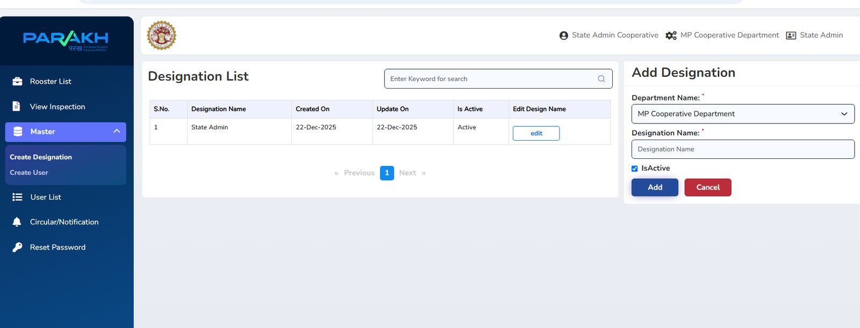
Figure 3.1 — Master > Create Designation Screen

The screen shows two panels:
- Left panel — Designation List: Shows all existing designations with Created/Updated dates and an Edit button.
- Right panel — Add Designation form: Used to create a new designation.

To add a new Designation:
- Step 1: Click Master in the left sidebar; click Create Designation.
- Step 2: The Designation List will load showing existing designations.
- Step 3: In the right panel (Add Designation), select the Department Name from the dropdown — e.g., "MP Cooperative Department".
- Step 4: Type the Designation Name in the text field (e.g., "Joint Commissioner", "Deputy Commissioner", "Nirikshankarta").
- Step 5: Ensure the IsActive checkbox is ticked (✓).
- Step 6: Click the Add button (नीले रंग का) to save.
- Step 7: The new designation will appear in the Designation List on the left.

✏️ To Edit an existing designation
In the Designation List, click the "edit" button next to the designation you want to change. The right panel will load the existing values. Make your changes and click Update.

3.2 Create User | उपयोगकर्ता बनाएँ
Go to: Master → Create User

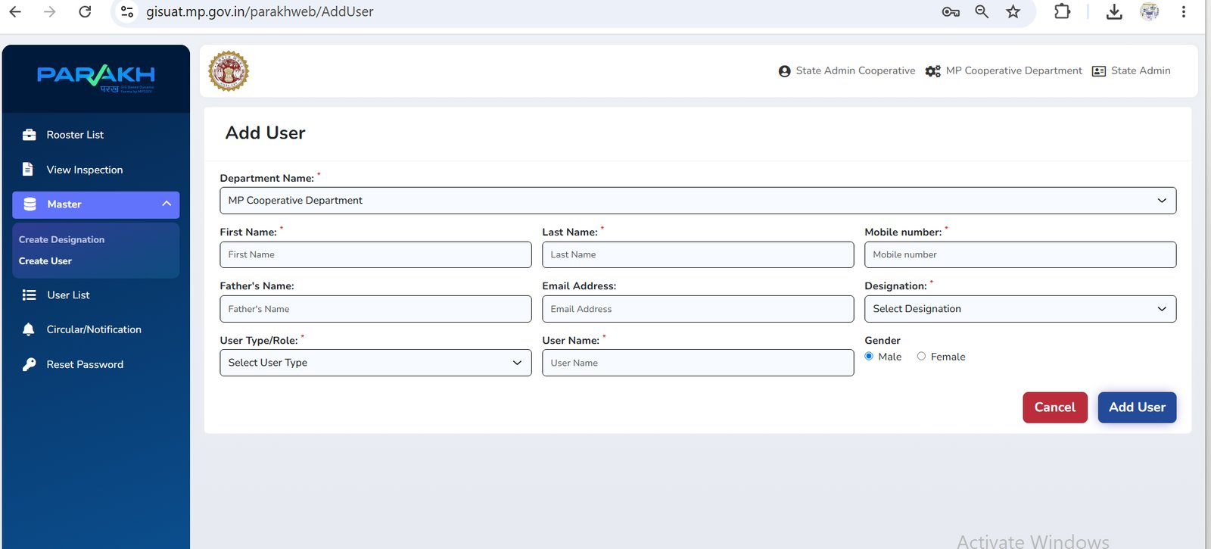
Figure 3.2 — Master > Add User Screen

Fill in all mandatory fields (marked with ✱):

Field | हिंदी नाम | Description / Notes
Department Name ✱ | विभाग का नाम | Auto-filled: MP Cooperative Department
First Name ✱ | प्रथम नाम | User's first name
Last Name ✱ | उपनाम | User's last name
Mobile Number ✱ | मोबाइल नंबर | 10-digit mobile number (used for OTP and notifications)
Father's Name | पिता का नाम | Optional
Email Address | ईमेल | Official email address
Designation ✱ | पदनाम | Select from designations created in Step 3.1
User Type / Role ✱ | उपयोगकर्ता प्रकार | Select: State Admin / Nodal Officer / Nirikshankarta
User Name ✱ | उपयोगकर्ता नाम | Unique login username (no spaces)
Gender | लिंग | Select: Male (पुरुष) / Female (महिला)

Steps to Create a User:
- Step 1: Navigate to Master → Create User.
- Step 2: The Department Name will be pre-set to "MP Cooperative Department".
- Step 3: Fill in First Name, Last Name, and Mobile Number (mandatory).
- Step 4: Enter Father's Name and Email Address (optional but recommended).
- Step 5: Select the correct Designation from the dropdown (must be pre-created in Section 3.1).
- Step 6: Select User Type / Role: State Admin, Nodal Officer, or Nirikshankarta (Surveyor).
- Step 7: Enter a unique User Name — this will be the login ID.
- Step 8: Select Gender: Male or Female.
- Step 9: Click the Add User button (dark blue) to save.
- Step 10: The system will create the account. A temporary password will be sent to the mobile number.

🔑 User Roles Explained | उपयोगकर्ता भूमिकाएँ
State Admin (राज्य एडमिन): Full access — creates rosters, manages all users, views all inspection reports.
Nodal Officer (नोडल अधिकारी): Views inspection progress for assigned divisions/districts; cannot create rosters.
Nirikshankarta / Surveyor (निरीक्षणकर्ता): Receives inspection order; fills and submits Nirikshan Prativedan (inspection report).

4. User List | उपयोगकर्ता सूची
Go to: User List (left sidebar)

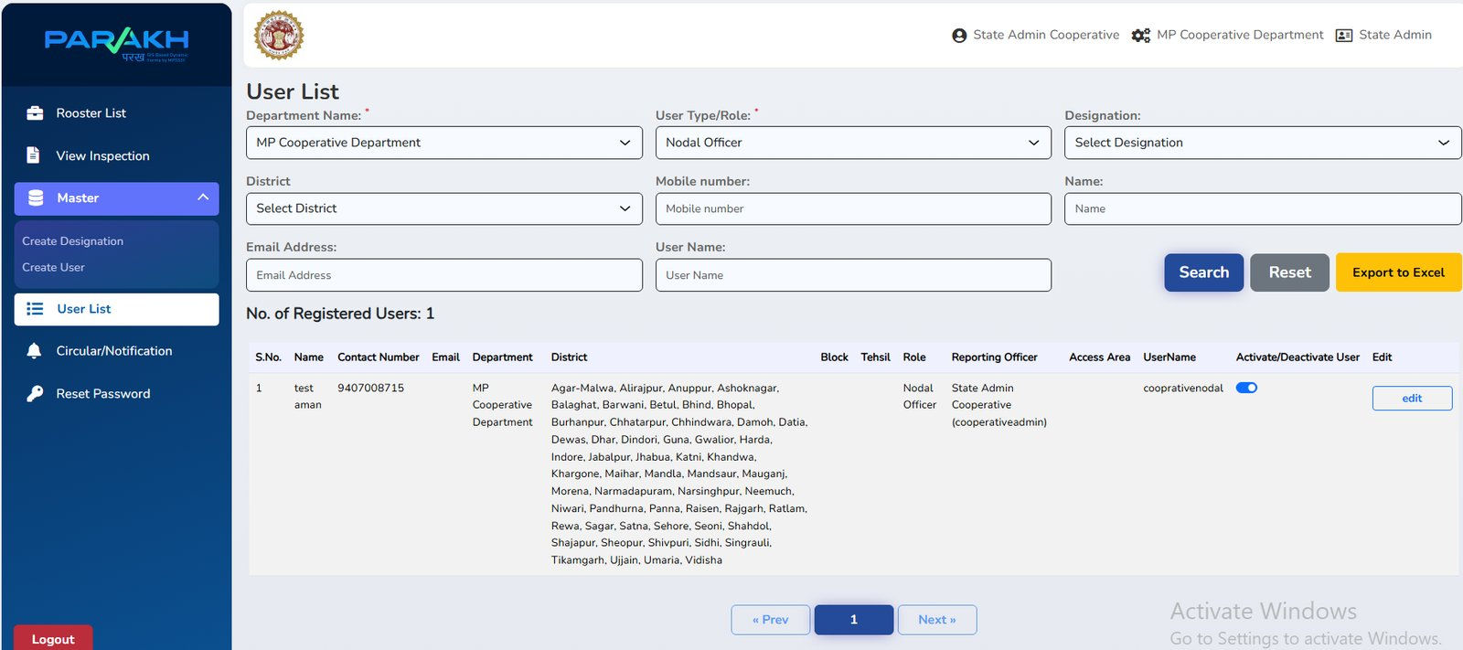
Figure 4.1 — User List Screen with search filters

The User List page allows you to search and manage all registered users.

4.1 Searching Users | उपयोगकर्ता खोजें
Use the filter fields at the top to search:

Filter Field | हिंदी नाम | How to use
Department Name | विभाग का नाम | Auto-set to MP Cooperative Department
User Type / Role | उपयोगकर्ता प्रकार | Filter by: Nodal Officer, State Admin, Nirikshankarta
Designation | पदनाम | Filter by specific designation
District | जिला | Filter users assigned to a specific district
Mobile Number | मोबाइल नंबर | Search by 10-digit mobile number
Name | नाम | Partial name search
Email Address | ईमेल | Search by email
User Name | उपयोगकर्ता नाम | Search by exact login username

- Step 1: Apply one or more filters.
- Step 2: Click the Search button (dark blue).
- Step 3: Results appear in the table below showing: Name, Contact Number, Email, Department, District, Role, Reporting Officer, Access Area, UserName.
- Step 4: Click Reset to clear all filters.
- Step 5: Click Export to Excel (yellow button) to download the list as an Excel file.

4.2 Editing a User | उपयोगकर्ता संपादित करें
- Step 1: Search for the user using the filters above.
- Step 2: In the results table, click the "edit" button on the right of the row.
- Step 3: Update the required fields.
- Step 4: Click Update / Save.

4.3 Activate / Deactivate a User | सक्रिय / निष्क्रिय करें
In the User List results, each row has an "Activate/Deactivate User" toggle switch (blue = active).
- To deactivate: click the toggle — it turns grey. The user will lose portal access.
- To re-activate: click the toggle again — it turns blue.

5. Rooster List — Inspection Roster | निरीक्षण रोस्टर
Go to: Rooster List (left sidebar)

The Rooster List is the central module for assigning annual inspection duties. The State Admin creates a roster that assigns Nirikshankarta officers to divisional and district offices.

5.1 Rooster List — Home Screen
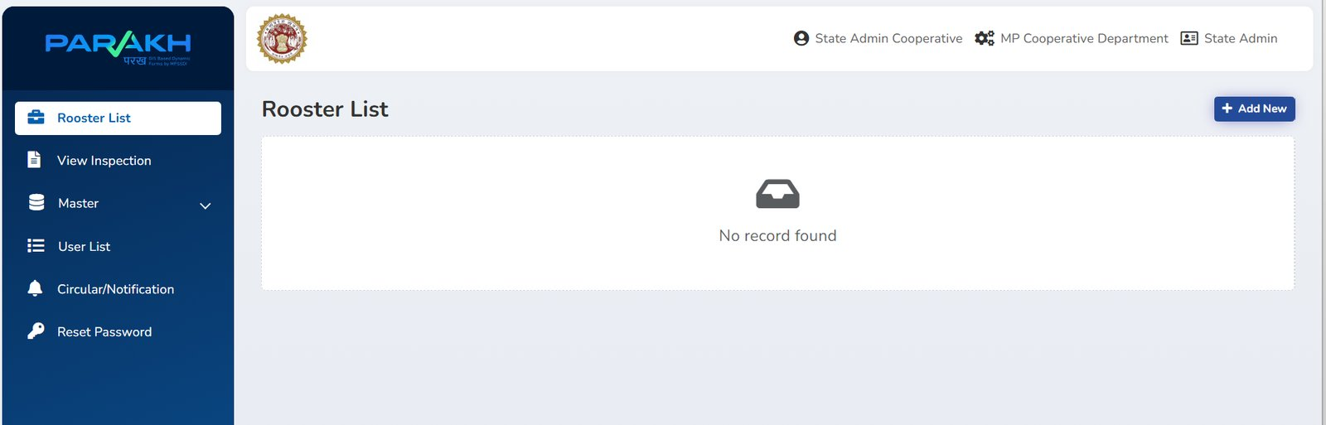
Figure 5.1 — Rooster List page (no rosters created yet)

When no roster has been created, the page shows "No record found" with an inbox icon.
Once rosters are created, they will appear here as a paginated list.

Column / Element | Description
+ Add New button | Click to open the Add Rooster dialog and create a new roster entry
List rows | Each row shows: Office Type, Division, District, Office Name, Surveyor assigned, and Action buttons
Edit button | Modify an existing roster entry before it is finalised
Delete button | Remove a roster entry (only before final submission)

5.2 Creating a New Inspection Roster | नया निरीक्षण रोस्टर बनाना
Step-by-step guide to add a roster entry:

- Step 1: On the Rooster List page, click the + Add New button (top-right, dark blue).

The Add Rooster dialog will open:

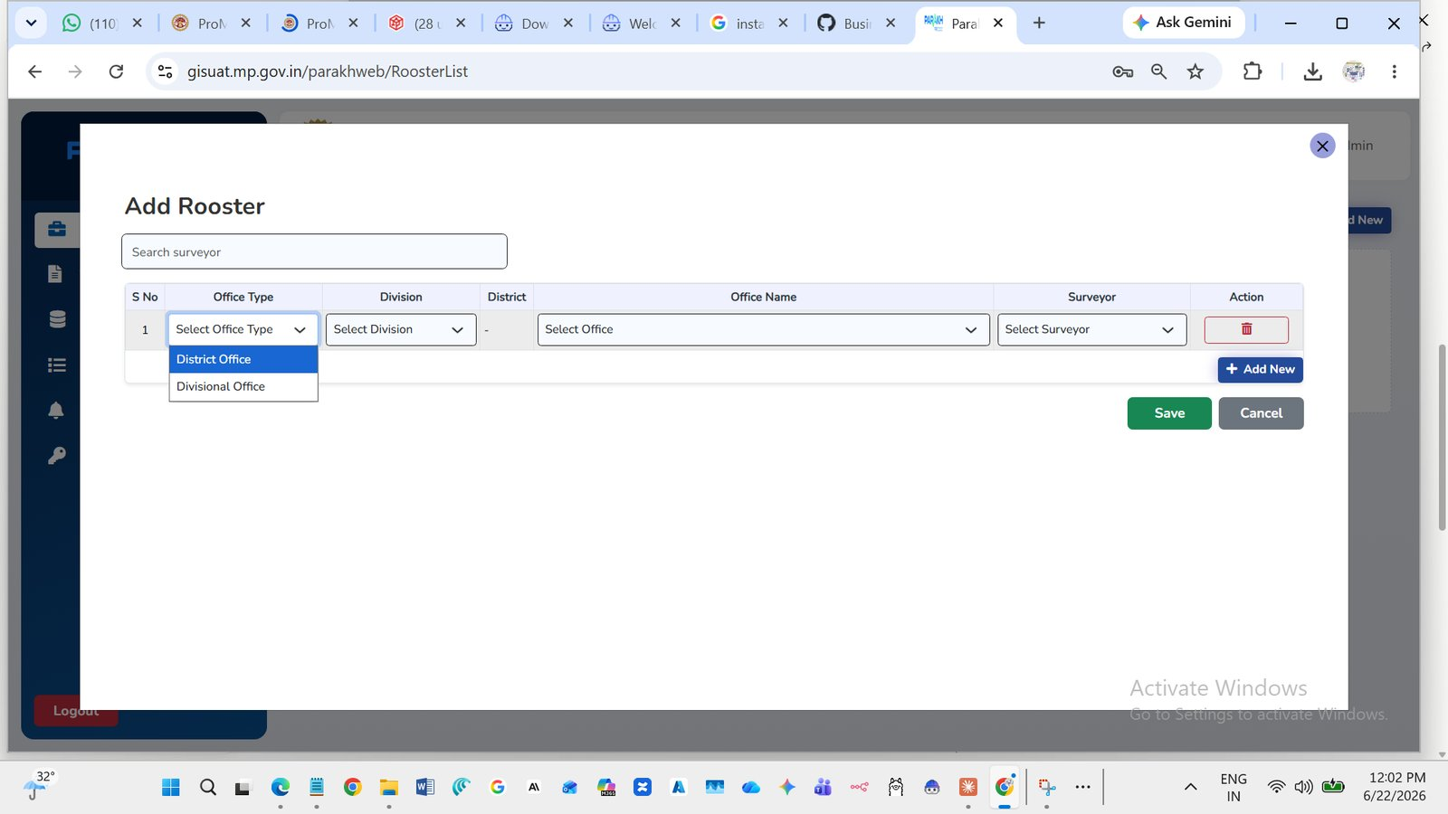
Figure 5.2a — Add Rooster dialog: Select Office Type

- Step 2: In the Office Type column, click the dropdown and select:
- District Office — for a Jila (District) level office (जिला कार्यालय)
- Divisional Office — for a Sambhag (Division) level office (संभागीय कार्यालय)

- Step 3: Click the Division dropdown and select the relevant division (संभाग):

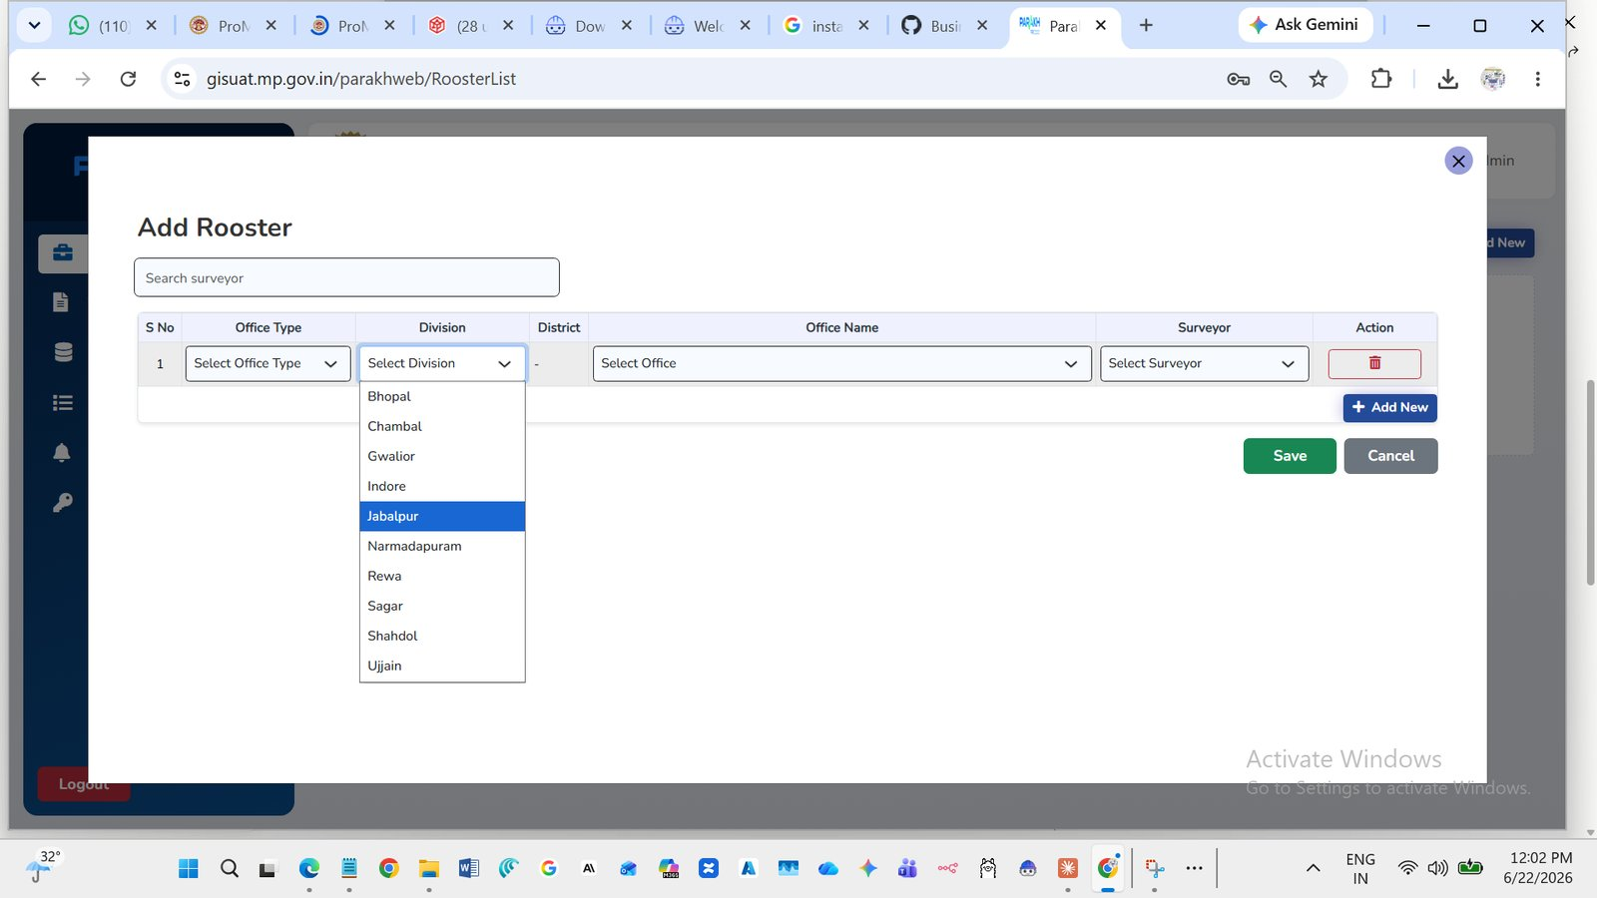
Figure 5.2b — Division dropdown showing all 10 MP Divisions

The 10 MP Divisions available are:

# | Division / संभाग | # | Division / संभाग
1 | Bhopal (भोपाल) | 6 | Narmadapuram (नर्मदापुरम)
2 | Chambal (चम्बल) | 7 | Rewa (रीवा)
3 | Gwalior (ग्वालियर) | 8 | Sagar (सागर)
4 | Indore (इंदौर) | 9 | Shahdol (शहडोल)
5 | Jabalpur (जबलपुर) | 10 | Ujjain (उज्जैन)

ℹ️ District field
When Office Type = District Office: the District field will auto-populate based on the Division selected. When Office Type = Divisional Office: the District field shows "−".

- Step 4: Click the Office Name dropdown and select the specific office to be inspected.

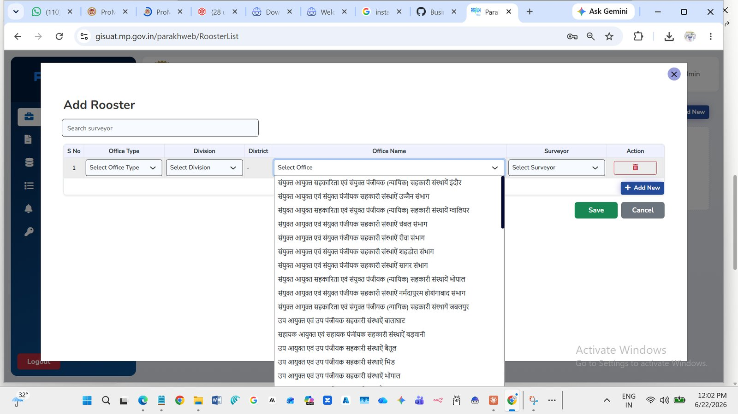
Figure 5.2c — Office Name dropdown showing available offices

The Office Name dropdown shows:
- Divisional offices — संयुक्त आयुक्त सहकारिता एवं संयुक्त पंजीयक (न्यायिक) offices per Sambhag
- District offices — उप आयुक्त एवं उप पंजीयक सहकारी संस्थाऐं per Jila
- Sub-district offices — सहायक आयुक्त एवं सहायक पंजीयक offices

- Step 5: In the Surveyor column, click the dropdown (or use the Search Surveyor field at the top of the dialog) to select the Nirikshankarta officer responsible for this inspection.

📌 Search Surveyor
Type a name in the "Search surveyor" field at the top of the Add Rooster dialog to quickly find a specific Nirikshankarta officer. The dropdown will filter in real time.

- Step 6: If you need to assign more offices, click + Add New (inside the dialog) to add another row. Repeat Steps 2–5 for each additional office.
- Step 7: Click the red trash icon (🗑) in the Action column to remove any incorrect row.
- Step 8: When all entries are correct, click the Save button (green).
- Step 9: To cancel without saving, click the Cancel button (grey).

⚠️ Important | महत्वपूर्ण
As per the Inspection Order instructions:
• Officers assigned to a Divisional Office (Upa Ayukta) must also inspect: Sahayak Ayukta (Ankekshan) and Sahayak Ayukta (Prashasan) offices of that division — these must be added as separate rows.
• उप आयुक्त आवंटित निरीक्षणकर्ता को सहायक आयुक्त (अंकेक्षण) एवं सहायक आयुक्त (प्रशासन) का भी निरीक्षण करना होगा।

6. View Inspection | निरीक्षण देखें
Go to: View Inspection (left sidebar)

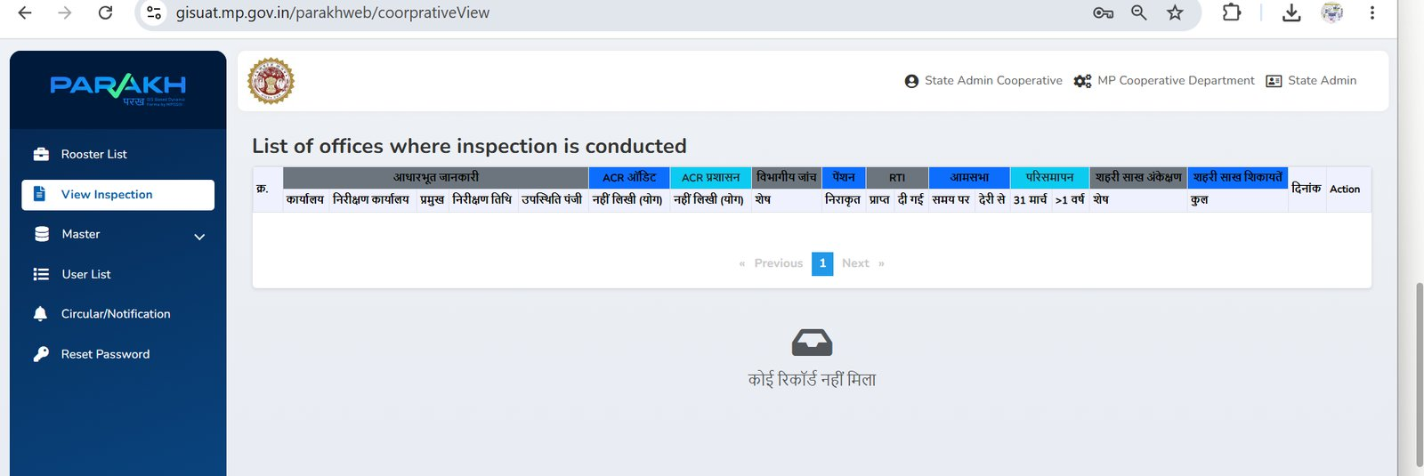
Figure 6.1 — View Inspection: List of offices where inspection is conducted

The View Inspection page shows a detailed inspection status table — "List of offices where inspection is conducted". This is the Admin Dashboard for tracking inspection progress.

6.1 Understanding the Table Columns
The table has multiple column groups, all with Hindi labels:

Column Group | Hindi Header | Sub-Columns / Description
Basic Info | आधारभूत जानकारी | कार्यालय (Office), निरीक्षण कार्यालय (Inspection Office), प्रमुख (Head), निरीक्षण तिथि (Inspection Date), उपस्थिति पंजी (Attendance Register)
ACR Audit | ACR ऑडिट | नहीं लिखी (योग) — ACRs not written (Audit category)
ACR Admin | ACR प्रशासन | नहीं लिखी (योग) — ACRs not written (Admin category)
Dept. Enquiry | विभागीय जांच | शेष (Pending department enquiries)
Pension | पेंशन | निराकृत (Disposed), प्राप्त (Received), दी गई (Given), समय पर (On time), देरी से (Delayed)
RTI | RTI | 31 मार्च, >1 वर्ष, शेष (March 31 / >1 year / Remaining)
Aam Sabha | आमसभा | General meetings data
Liquidation | परिसमापन | Society liquidation status
Urban Credit Audit | शहरी साख अंकेक्षण | Urban credit society audit data — कुल (Total)
Urban Credit Complaints | शहरी साख शिकायतें | Urban credit society complaints
Date | दिनांक | Date of inspection
Action | Action | View / Download inspection report

6.2 Using the Dashboard
- When no inspections have been submitted yet: the table shows "कोई रिकॉर्ड नहीं मिला" (No record found).
- Once a Nirikshankarta submits an inspection report, a row appears with all the summary statistics auto-populated from the report.
- Click the Action button in any row to view the full Nirikshan Prativedan (inspection report) for that office.
- Use the Previous / Next buttons at the bottom to navigate pages.

📊 Dashboard Tip | डैशबोर्ड टिप
The Commissioner and Nodal Officers should check the View Inspection page regularly to:
1. Monitor which offices have been inspected and which are pending.
2. Identify offices where ACRs are overdue or RTI responses are delayed.
3. Track pension and departmental enquiry resolution rates.
4. Take follow-up action for overdue inspections (विलंबित निरीक्षण).

7. Circular / Notification | परिपत्र / अधिसूचना
Go to: Circular/Notification (left sidebar)

This section allows the State Admin to issue department circulars and notifications to all portal users. Field officers (Nirikshankarta) can view circulars relevant to their inspections here.

7.1 Viewing Notifications
- Click Circular/Notification in the left sidebar.
- A list of all active circulars and notifications will be displayed with date, title, and issued-by details.
- Click on any circular to read its full content.

7.2 Issuing a Notification (State Admin only)
- Step 1: Navigate to Circular/Notification.
- Step 2: Click + Add New or Issue Notification (button placement as shown on screen).
- Step 3: Enter the Notification Title and full text.
- Step 4: Select the target audience (all users / specific role / specific district).
- Step 5: Click Submit to publish.

8. Reset Password | पासवर्ड बदलें
Go to: Reset Password (left sidebar)

- Step 1: Click Reset Password in the left sidebar.
- Step 2: Enter your Current Password (वर्तमान पासवर्ड).
- Step 3: Enter your New Password (नया पासवर्ड) — minimum 8 characters.
- Step 4: Re-enter the New Password in the Confirm Password field.
- Step 5: Click Submit / Update.

🔒 Password Policy | पासवर्ड नीति
Password must be at least 8 characters long. It should include uppercase letters, lowercase letters, numbers, and a special character (e.g., @, #, $).
यदि पासवर्ड भूल गए हों तो System Administrator से संपर्क करें या पंजीकृत मोबाइल पर OTP प्राप्त करें।

9. Inspection Workflow — Quick Reference | प्रक्रिया संदर्भ
Complete end-to-end flow from roster creation to report viewing:

# | Who / कौन | Action / कार्रवाई | Where in Portal / पोर्टल में कहाँ
1 | State Admin  (राज्य एडमिन) | Open Parakh Portal; go to Rooster List | Rooster List → (empty page shown)
2 | State Admin | Click + Add New to open Add Rooster dialog | Rooster List → + Add New
3 | State Admin | Select Office Type → Division → District → Office Name → Surveyor for each row | Add Rooster dialog
4 | State Admin | Click + Add New (inside dialog) to add more rows; Click Save when done | Add Rooster dialog → Save
5 | System (auto) | Inspection assignment is saved; Nirikshankarta can now see assigned offices | System
6 | Nirikshankarta  (निरीक्षणकर्ता) | Login; receive assignment; conduct field inspection at allocated office | Field visit (offline)
7 | Nirikshankarta | Fill Nirikshan Prativedan (48-section form) in portal; save draft | Inspection Form
8 | Nirikshankarta | Final Submit + OTP e-Sign the completed report | Inspection Form → Submit
9 | State Admin /  Nodal Officer | View submitted report summary on View Inspection page | View Inspection
10 | State Admin /  Nodal Officer | Download full inspection report (PDF / Excel) | View Inspection → Action

10. Troubleshooting | समस्या निवारण
Issue / समस्या | Probable Cause / संभावित कारण | Solution / समाधान
Cannot login  लॉगिन नहीं हो रहा | Wrong username or password | Use Reset Password option, or contact State Admin to reset credentials
"No record found" in Rooster List  रोस्टर सूची में कोई रिकॉर्ड नहीं | No roster created yet | Click + Add New to create the first roster entry
Office Name dropdown is empty  कार्यालय नाम ड्रॉपडाउन खाली है | Division not selected first | First select Office Type and Division; Office Name will auto-populate
Surveyor not found in dropdown  सर्वेयर नहीं मिल रहा | User not created in the system | Go to Master → Create User to register the officer; ensure role = Nirikshankarta
View Inspection shows no data  निरीक्षण डेटा नहीं दिख रहा | No inspections submitted yet | Data appears only after a Nirikshankarta submits a completed report
OTP not received  OTP प्राप्त नहीं हुआ | Wrong mobile number or network issue | Check registered mobile number in User List; retry after 2 minutes; contact State Admin
Page not loading / slow  पेज धीरे लोड हो रहा | Low internet speed or browser cache | Use Chrome; clear browser cache (Ctrl+Shift+Delete); ensure ≥2 Mbps internet speed
Export to Excel not working  Excel डाउनलोड नहीं हो रहा | Browser blocking popups | Allow popups for gisuat.mp.gov.in in browser settings

11. Quick Tips | त्वरित सुझाव
- Always use Google Chrome or Mozilla Firefox for the best experience.
- Use the Search Surveyor field in the Add Rooster dialog to quickly find officers — avoid scrolling the dropdown.
- निरीक्षण रोस्टर बनाते समय एक बार में सभी कार्यालय जोड़ें ताकि आदेश एक साथ जारी हो सके।
- Export the User List to Excel regularly to maintain an offline backup of user accounts.
- Nodal Officers should check the View Inspection page weekly to track progress in their division.
- For password changes, use Reset Password from the left sidebar — do not share your password with anyone.
- यदि किसी Nirikshankarta को एक से अधिक कार्यालय आवंटित हैं, तो प्रत्येक के लिए Add Rooster में अलग पंक्ति (row) जोड़ें।

12. Glossary | शब्दकोश
Term | Hindi / हिंदी | Meaning
Rooster / Roster | रोस्टर | Annual schedule assigning inspection officers to cooperative offices
Nirikshan | निरीक्षण | Inspection (annual office inspection)
Nirikshan Prativedan | निरीक्षण प्रतिवेदन | 48-section digital inspection report form
Nirikshankarta | निरीक्षणकर्ता | Inspection Officer (field inspector); same as "Surveyor" in system
Surveyor | सर्वेयर | System term for Nirikshankarta (inspection officer)
State Admin | राज्य एडमिन | Commissioner-level user with full portal access
Nodal Officer | नोडल अधिकारी | Divisional/district-level monitoring officer
Sambhag | संभाग | Division (one of 10 administrative divisions in MP)
Divisional Office | संभागीय कार्यालय | Joint Commissioner's office at division level
District Office | जिला कार्यालय | Deputy Commissioner's office at district level
ACR | वार्षिक चरित्रावली | Annual Confidential Report (employee performance appraisal)
RTI | सूचना का अधिकार | Right to Information (RTI Act 2005)
Aam Sabha | आमसभा | General Meeting of cooperative society members
Parismaapan | परिसमापन | Liquidation of a cooperative society
OTP | OTP | One-Time Password (used for digital signature/e-sign)
e-Sign | ई-हस्ताक्षर | Digital signature via OTP for inspection orders and reports
ICMIS | ICMIS | Integrated Cooperative Management Information System (icmis.mp.gov.in)
eHRM | eHRM | Electronic Human Resource Management portal
Parakh | परख | Government GIS-based inspection monitoring platform

— End of User Manual | उपयोगकर्ता पुस्तिका समाप्त —

